Instructions to Execute The Program From Command Line:-

------------------------------------------------------------------------------

1.Unzip the zip file.

2.Import the project (PiglatinLanguageConversion) as a maven project into Eclipse IDE

3.Open the command prompt in the machine

Navigate to the path src/Languageconversion/PiglatinConversion by

using cd (followed by the name of the folder) in the command prompt

In this case,cd PiglatinLanguageConversion

4.Run the command - mvn clean install

This command will perform a Maven Build

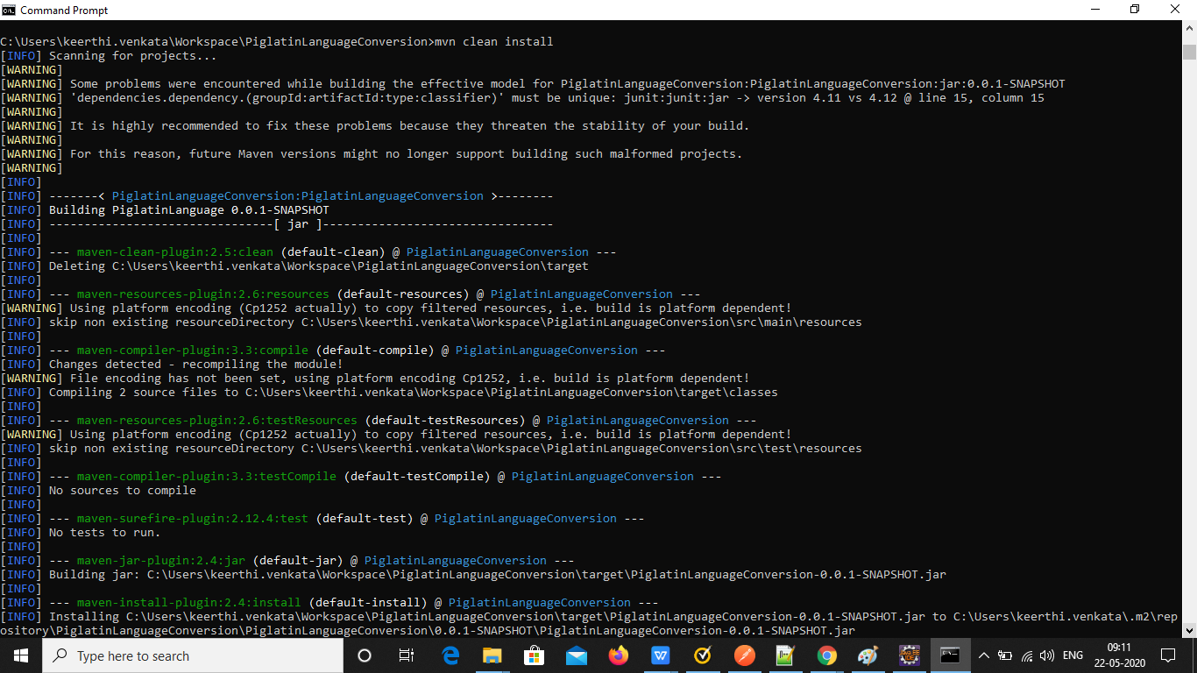

5.Run the command mvn exec:java -Dexec.mainClass=Languageconversion.PiglatinConversion

This command will then ask you for the input

and you can see the output

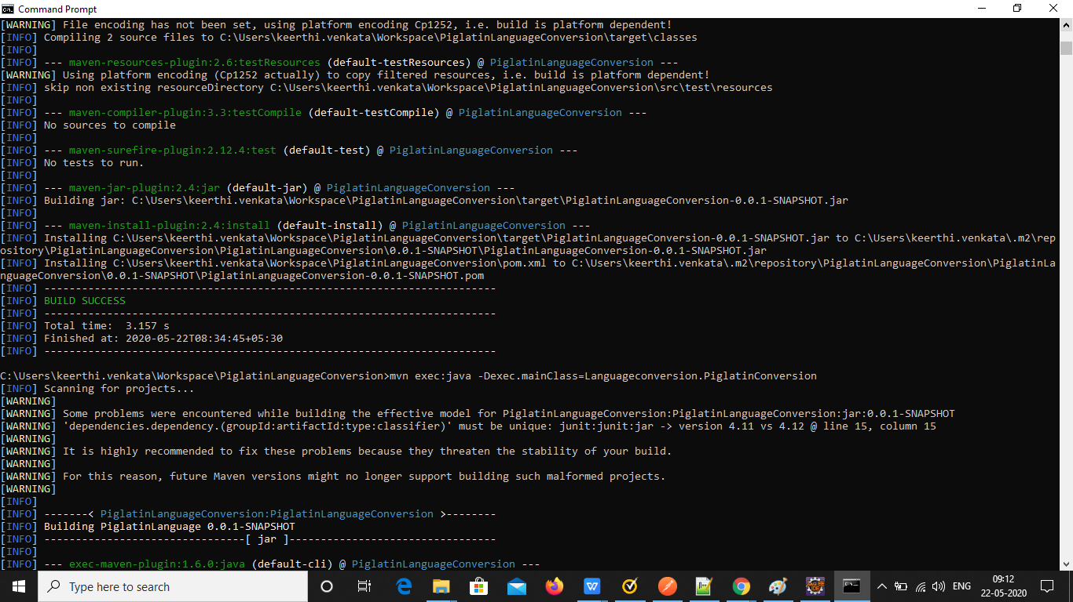

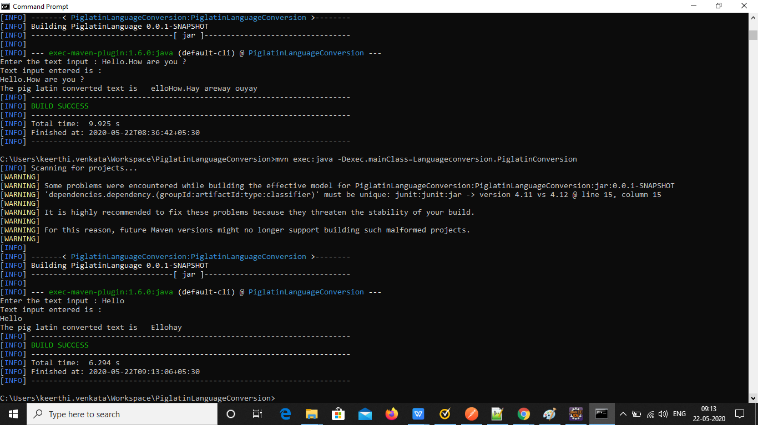

Instructions to Execute The Program From Eclipse IDE:-

-------------------------------------------------------------------------

1.Unzip the zip file.

2.Import the project (PiglatinLanguageConversion) as a maven project into Eclipse IDE

3.Navigate to the file src/Languageconversion/PiglatinConversion.java

4.Right click on the file PiglatinConversion.java

5.Select Run As -> Java Application

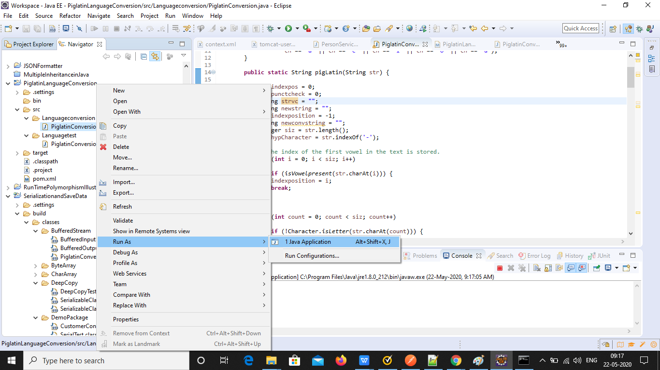

6.You can now enter the input in the console and see the output

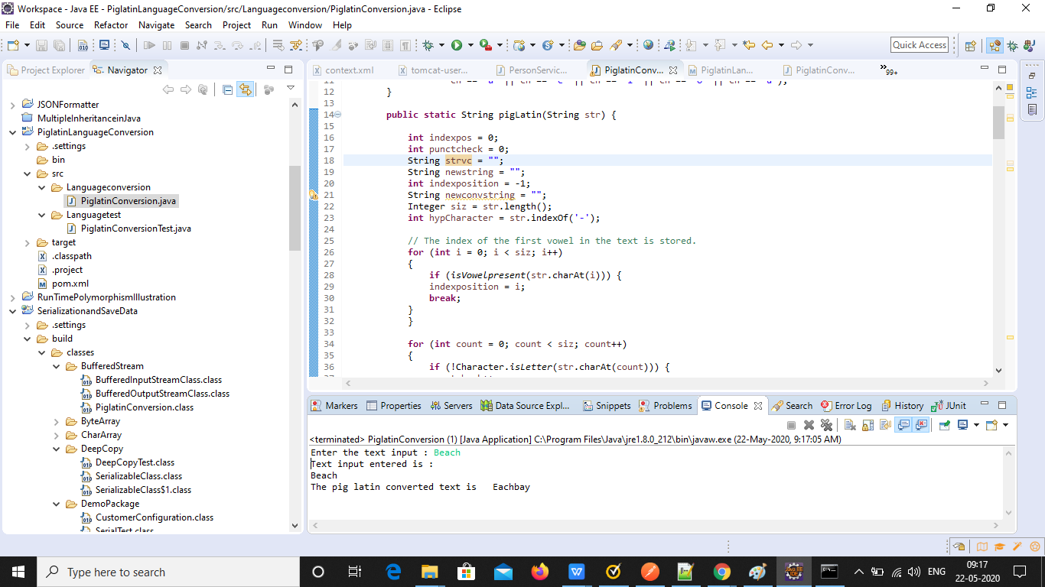

Instructions to Execute The JUnit Tests From Eclipse IDE

----------------------------------------------------------------------------

1.Uncomment the commented PiglatinConversionTest code.

Uncommented code looks like below

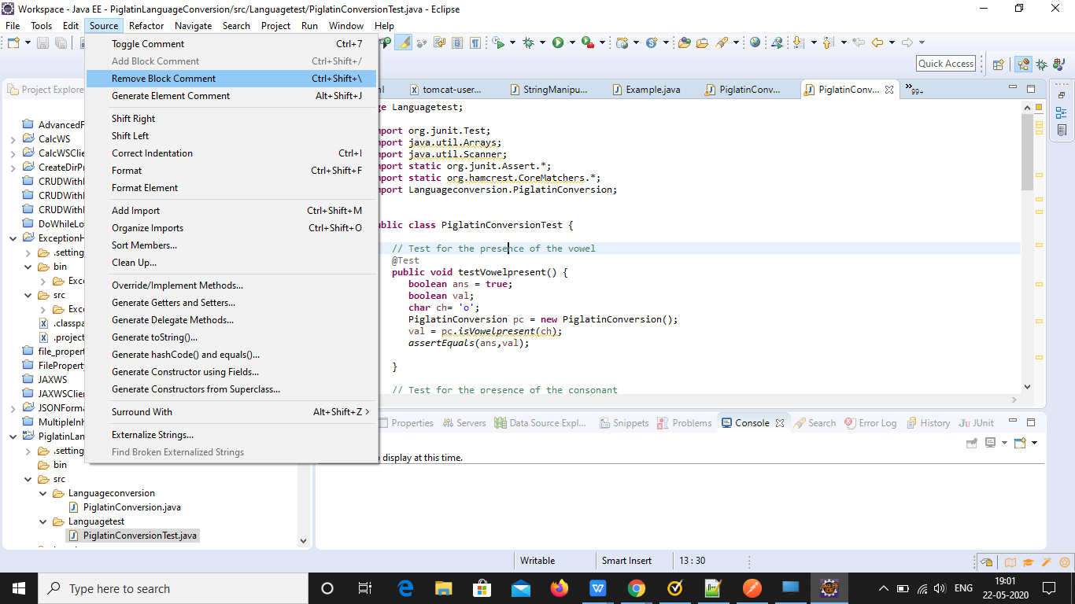

package Languagetest;

import org.junit.Test;

import java.util.Arrays;

import java.util.Scanner;

import static org.junit.Assert.\*;

import static org.hamcrest.CoreMatchers.\*;

import Languageconversion.PiglatinConversion;

public class PiglatinConversionTest {

// Test for the presence of the vowel

@Test

public void testVowelpresent() {

boolean ans = true;

boolean val;

char ch= 'o';

PiglatinConversion pc = new PiglatinConversion();

val = pc.isVowelpresent(ch);

assertEquals(ans,val);

}

// Test for the presence of the consonant

@Test

public void testConsonantpresent() {

boolean ans = true;

boolean val;

char ch= 'H';

PiglatinConversion pc = new PiglatinConversion();

val = pc.isVowelpresent(ch);

assertFalse(val);

}

@Test

// Test for the pig latin conversion of the Consonant Start Letter

public void pigLatinConsonantStartLetterTest() {

String actualres;

String expectedres;

PiglatinConversion pc = new PiglatinConversion();

actualres = pc.pigLatin("where");

expectedres = "hereway";

assertEquals(expectedres,actualres);

}

@Test

// Test for the pig latin conversion of the Vowel Start Letter

public void pigLatinVowelStartLetterTest() {

String actualres;

String expectedres;

PiglatinConversion pc = new PiglatinConversion();

actualres = pc.pigLatin("Orange");

expectedres = "Orangeway";

assertEquals(expectedres,actualres);

}

@Test

// Test for the pig latin conversion of Capital Letter

public void pigLatinCapitalLetterTest() {

String actualres;

String expectedres;

PiglatinConversion pc = new PiglatinConversion();

actualres = pc.pigLatin("Beach");

expectedres = "Eachbay";

assertEquals(expectedres,actualres);

}

@Test

// Test for unmodified way suffixed words

public void pigLatinWayTest() {

String actualres;

String expectedres;

PiglatinConversion pc = new PiglatinConversion();

actualres = pc.pigLatin("runway");

expectedres = "runway";

assertEquals(expectedres,actualres);

}

}

2.Right click on the PiglatinConversionTest file

3.Select Run As -> JUnit Test

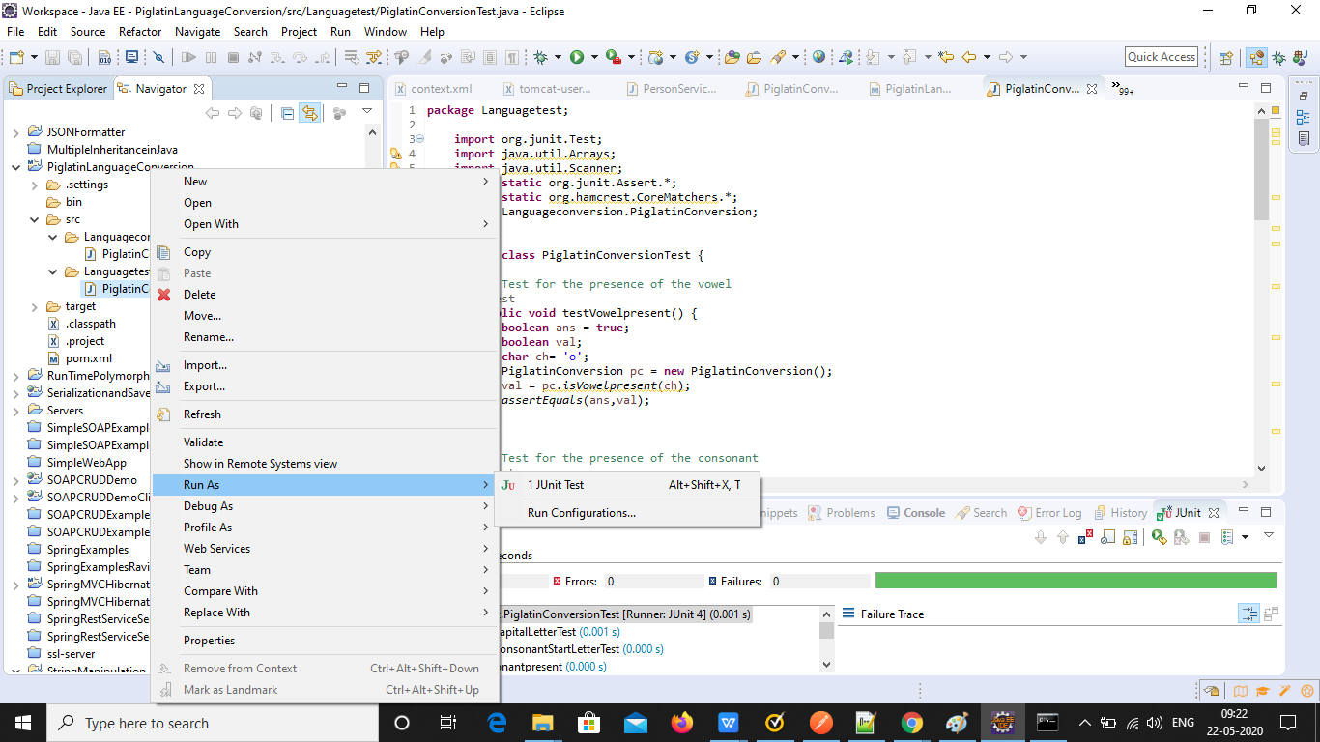

4.All the tests will be executed and the test result which is all positive (as seen in the below picture) will be shown in the console.

